Book Backdrops: Connecting Literature and Primary Sources

Note: Sources included in a Book Backdrop should enrich or extend understanding of the theme, historical topic, or time period rather than serve as illustration.

Created by:
Date:

Book Cover  Image | Title:  Author:  Grade Level(s):  Book Type/Genre:  Major Topic/Theme:  Setting and Time Period:
Primary Source  Thumbnail | Title/Caption  Publication Information  URL  Book Notes (Indicate how each source relates to the book and how it will be used to develop content or contextual understanding.
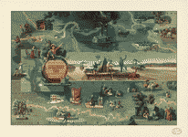  ICONIC IMAGE | Title: The adventures of Huckleberry Finn from the book by Mark Twain: [Mississippi River]  Creator(s): Henry, Everett.  Date Created/Published: c1959.  https://www.loc.gov/item/93686470/  Book Notes: Each group of students will use this map, along with a geographic map of the Mississippi, to mark the locations depicted in the story.

Submit final version in MS Word to be considered for publication on the TPS Eastern Region webpage. Please choose a primary source to represent this Book Backdrop by typing “ICONIC IMAGE” below the selected thumbnail above.

